**18PDH103T Social Engineering Project**

As we know that there is something called **QUOTA (**Also called as Reservation System**)** due to which many aspiring students lose their seats to a political idea where some minorities get some predefined number of seats and as a result there are very few general quota seats as per the demand.

This quota is getting misused and therefore we are proposing that this quota system shall be removed and instead some financial or material help be provided to those who actually need it.

We propose a social business idea that promotes and works towards the same while providing a well-functioning digital learning platform for the same. We shall focus upon reservation for educational seats only, i.e., for university seats and enrollment.

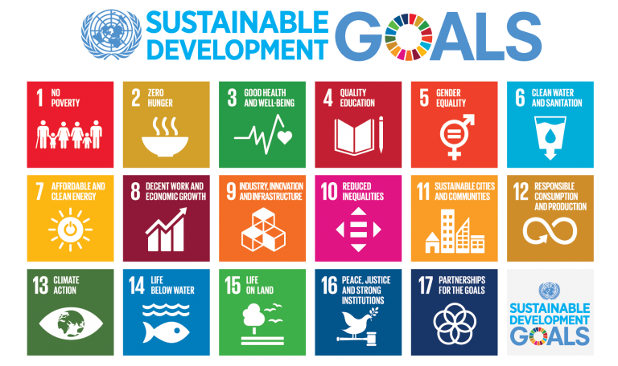

We are trying to fulfil the goals number **4** and **10** by providing quality education through the digital learning platform and reduced inequality by providing proper help to those who actually need it.

**History**

After the independence of India in 1947 there were some major initiatives in favour of the STs, SCs and after the 1980s in favour of OBCs (Other Backward Castes) and in 2019 for poor in the general category. The country's affirmative action program was launched in 1950 and is the oldest such programme in the world.

A common form of caste discrimination in India was the practice of untouchability. SCs were the primary targets of the practice, which was outlawed by the new Constitution of India.

In 1954, the Ministry of Education suggested that 20 percent of places should be reserved for the SCs and STs in educational institutions with a provision to relax minimum qualifying marks for admission by 5 percent wherever required. In 1982, it was specified that 15 percent and 7.5 percent of vacancies in [public sector](https://en.wikipedia.org/wiki/Public_sector) and government-aided educational institutes should be reserved for the SC and ST candidates, respectively.

A significant change began in 1979 when the Mandal Commission or the Socially and Educationally Backward Classes (SEBC) Commission was established to assess the situation of the socially and educationally backward classes. The commission did not have exact population figures for the OBCs and so used data from the [1931 census](https://en.wikipedia.org/wiki/Census_of_India_prior_to_independence), thus estimating the group's population at 52 per cent. In 1980, the commission's report recommended that a reserved quota for OBCs of 27 per cent should apply in respect of services and public sector bodies operated by the Union Government. It called for a similar change to admissions to institutes of higher education, except where states already had more generous requirements. It was not until the 1990s that the recommendations were implemented in Union Government jobs. In 2019 the government announces the 10% reservation in educational institutions and government jobs for economically weaker section of the general category.

The Constitution of India states in article 15(4): "Nothing in [article 15] or in clause (2) of article 29 shall prevent the State from making any special provision for the advancement of any socially, and educationally backward classes of citizens of or for the Scheduled Castes and the Scheduled Tribes." Article 46 of the Constitution states that "The State shall promote with special care the educational and economic interests of the weaker sections of the people, and, in particular, of the Scheduled Castes and the Scheduled Tribes, and shall protect them from social injustice and all forms of exploitation."

The [Supreme Court of India](https://en.wikipedia.org/wiki/Supreme_Court_of_India) ruled in 1992 that reservations could not exceed 50 percent, anything above which it judged would violate equal access as guaranteed by the Constitution. It thus put a cap on reservations. However, the recent amendment of the constitution exceeds 50% and also there are state laws that exceed this 50 percent limit and these are under litigation in the Supreme Court. For example, in the State of [Tamil Nadu](https://en.wikipedia.org/wiki/Tamil_Nadu), the caste-based reservation stands at 69 percent and applies to about 87 percent of the population.

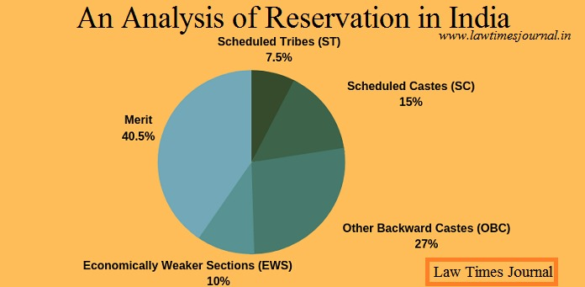

**General Problems with Reservation**

* **Encouraging casteism:** It’s propagating the notion of caste-based society instead of eliminating it.
* **Chances of creating more castes in the society:** Poor people from the forward castes still don’t have any social or economic advantage over the rich people from the backward castes. If this situation persists, it may result in the formation of a separate backward caste of people belonging from the poorer section of the forward castes.
* **The benefit of the privileged only:** Beneficiaries of reservation are primarily from the creamy layer or the dominant class in backward castes. Hence, the marginalized section still remains marginalized.
* **Opposing meritocracy:** It’s resulting in the degradation of the quality of students and employees enrolled in different institutions if the undeserving candidates get the opportunities.
* **Short-term relief:**A reservation only provides a limited and short-term solution to the historical injustice issues.
* **The privileged getting more privileged:** As the reservation grows more prominent, it becomes a mechanism of exclusion rather than inclusion. As we can see nowadays, the previously advantaged communities have becoming disadvantaged to a large extent due to the reservation problem. Many deserving people from the upper castes are still affected by poverty and illiteracy.
* **A barrier between ethnicities:** It is a form of ethnic discrimination. It works as a barrier for removing casteism and racism and promoting harmony between castes and religions.
* **Social unrest:** Reservation agitations may cause social unrest, such as during the Mandal Commission (1990).
* **This reservation is being misused as just a political get-out-of-jail-free card** **where whoever offers more “freebies” in terms of his “QUOTA” gets the vote.**
* **A lot of people belonging to minorities actually are financially capable enough to reach their goals without this quota system but they still utilize this and thus taking this opportunity away from those who actually need it. (Corruption)**

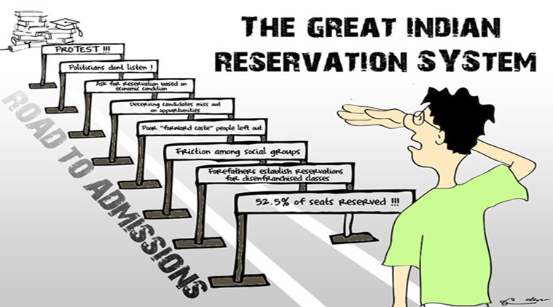

**Our Solution**

We aim to show that by providing the means of getting to where you deserve to be is a better way of improving diversity. No one should be looked down upon as a result of “Quota Category” and actually earn their keep.

Quota system was started with a basic idea of uplifting minorities who had very little resources as compared to the “Giants” and therefore had no means of getting to the top (Eg: Like an IIT for other prestige institutions). We want to provide them with the means: Financial, Material, Digital Learning or otherwise; so that there is fairness amongst competitors while keeping the doors for diversity wide open. Stringent background checks will be done before supporting the talent so that this helping hand is not misused. A proper Digital Learning platform shall also be started so that these talents get the preparation they deserve.

**Marketing Strategy**

* Doing surveys and making some activities to create general awareness amongst people.
* Also, we shall push the govt. to push on with the same and promote our ideas as well as use the available resources offered by the govt. for the same.
* We will reel in companies trying to fulfill their CSR and use their resources to advertise the campaign.
* Using easily available info sources for adverts like radios and newspapers.
* Once it gets some popularity, we shall use word-of-mouth to our advantage.

**SUBMITTED BY:**

**VIGHNESH PRADHAN(RA2011030010180)**

**HEMACHANDU B V(RA2011030010200)**

**PURAB SINGH THAKUR(RA2011030010204)**

**HARSHIT SHARMA(RA2011030010206)**

**KARAN PANDITA(RA2011030010216)**

**SOORAJ TOMAR(RA2011030010224)**